CyFun Compliance for Log360
Strengthen cybersecurity and meet CyFun compliance with Log360.
Region: USA, EU, Belgium, International | Type: Cybersecurity Framework, Industry Standard, Incident Management | Category: Compliance | Pricing: Free

Overview
The CyFun compliance extension in Log360 helps organizations meet the CyberFundamentals Framework (CyFun), Belgium's national cybersecurity framework based on NIST CSF, ISO 27001, CIS Controls, and IEC 62443 with four assurance levels recognized for NIS2 compliance by providing centralized log management, continuous threat detection, access auditing, and incident response. The platform supports CyFun requirements for asset identification, vulnerability assessment, access protection, data security, security monitoring, anomaly detection, incident response, and recovery planning.
For Identify: Asset Management and Vulnerability Assessment, Log360 integrates asset inventory data with vulnerability scan results to support risk-based asset management. To address Protect: Access Control and Authentication, the platform monitors all authentication events across Windows, Unix, Active Directory, and cloud identity platforms. The extension also supports Protect: Data Security and Privacy Controls by providing capabilities that provides continuous file audit and data protection monitoring to enforce CyFun data security requirements.

Key Features
- Detect: Security Monitoring and Anomaly Detection: Log360 consolidates security telemetry from all sources to enable SIEM-based detection aligned with CyFun maturity levels.
- Respond: Incident Response and Communication: Log360 supplies the forensic log data and real-time alerts needed to support incident response at all CyFun assurance levels.
- Identify: Asset Management and Vulnerability Assessment: Log360 integrates asset inventory data with vulnerability scan results to support risk-based asset management.
- Protect: Access Control and Authentication: Log360 monitors all authentication events across Windows, Unix, Active Directory, and cloud identity platforms.


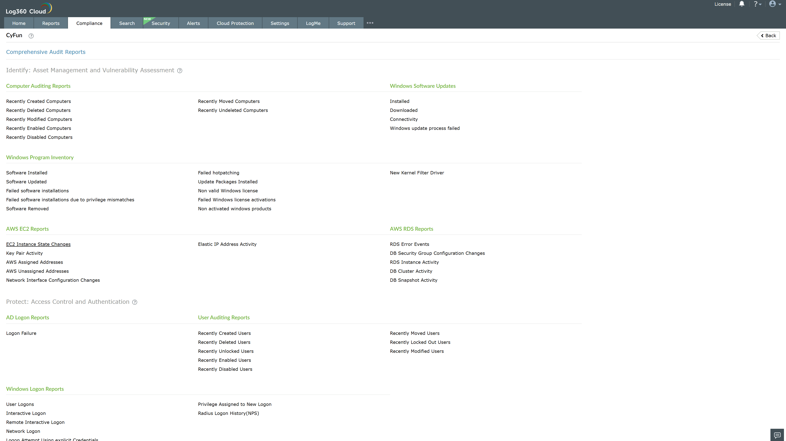
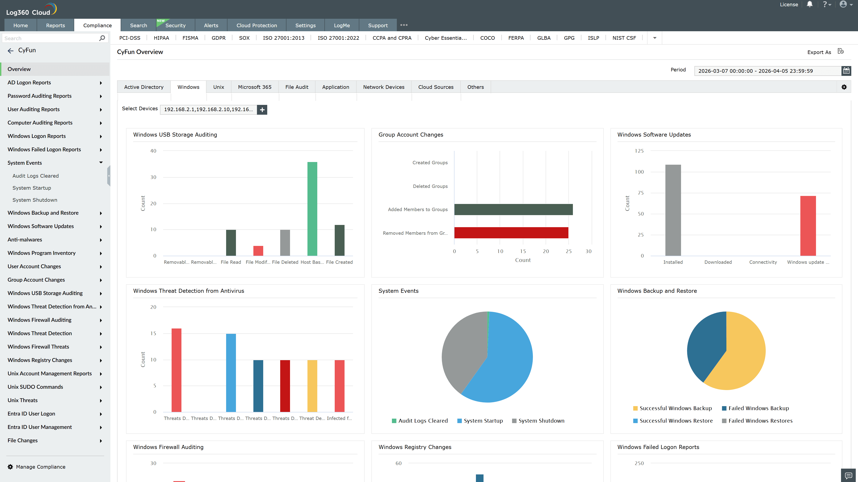
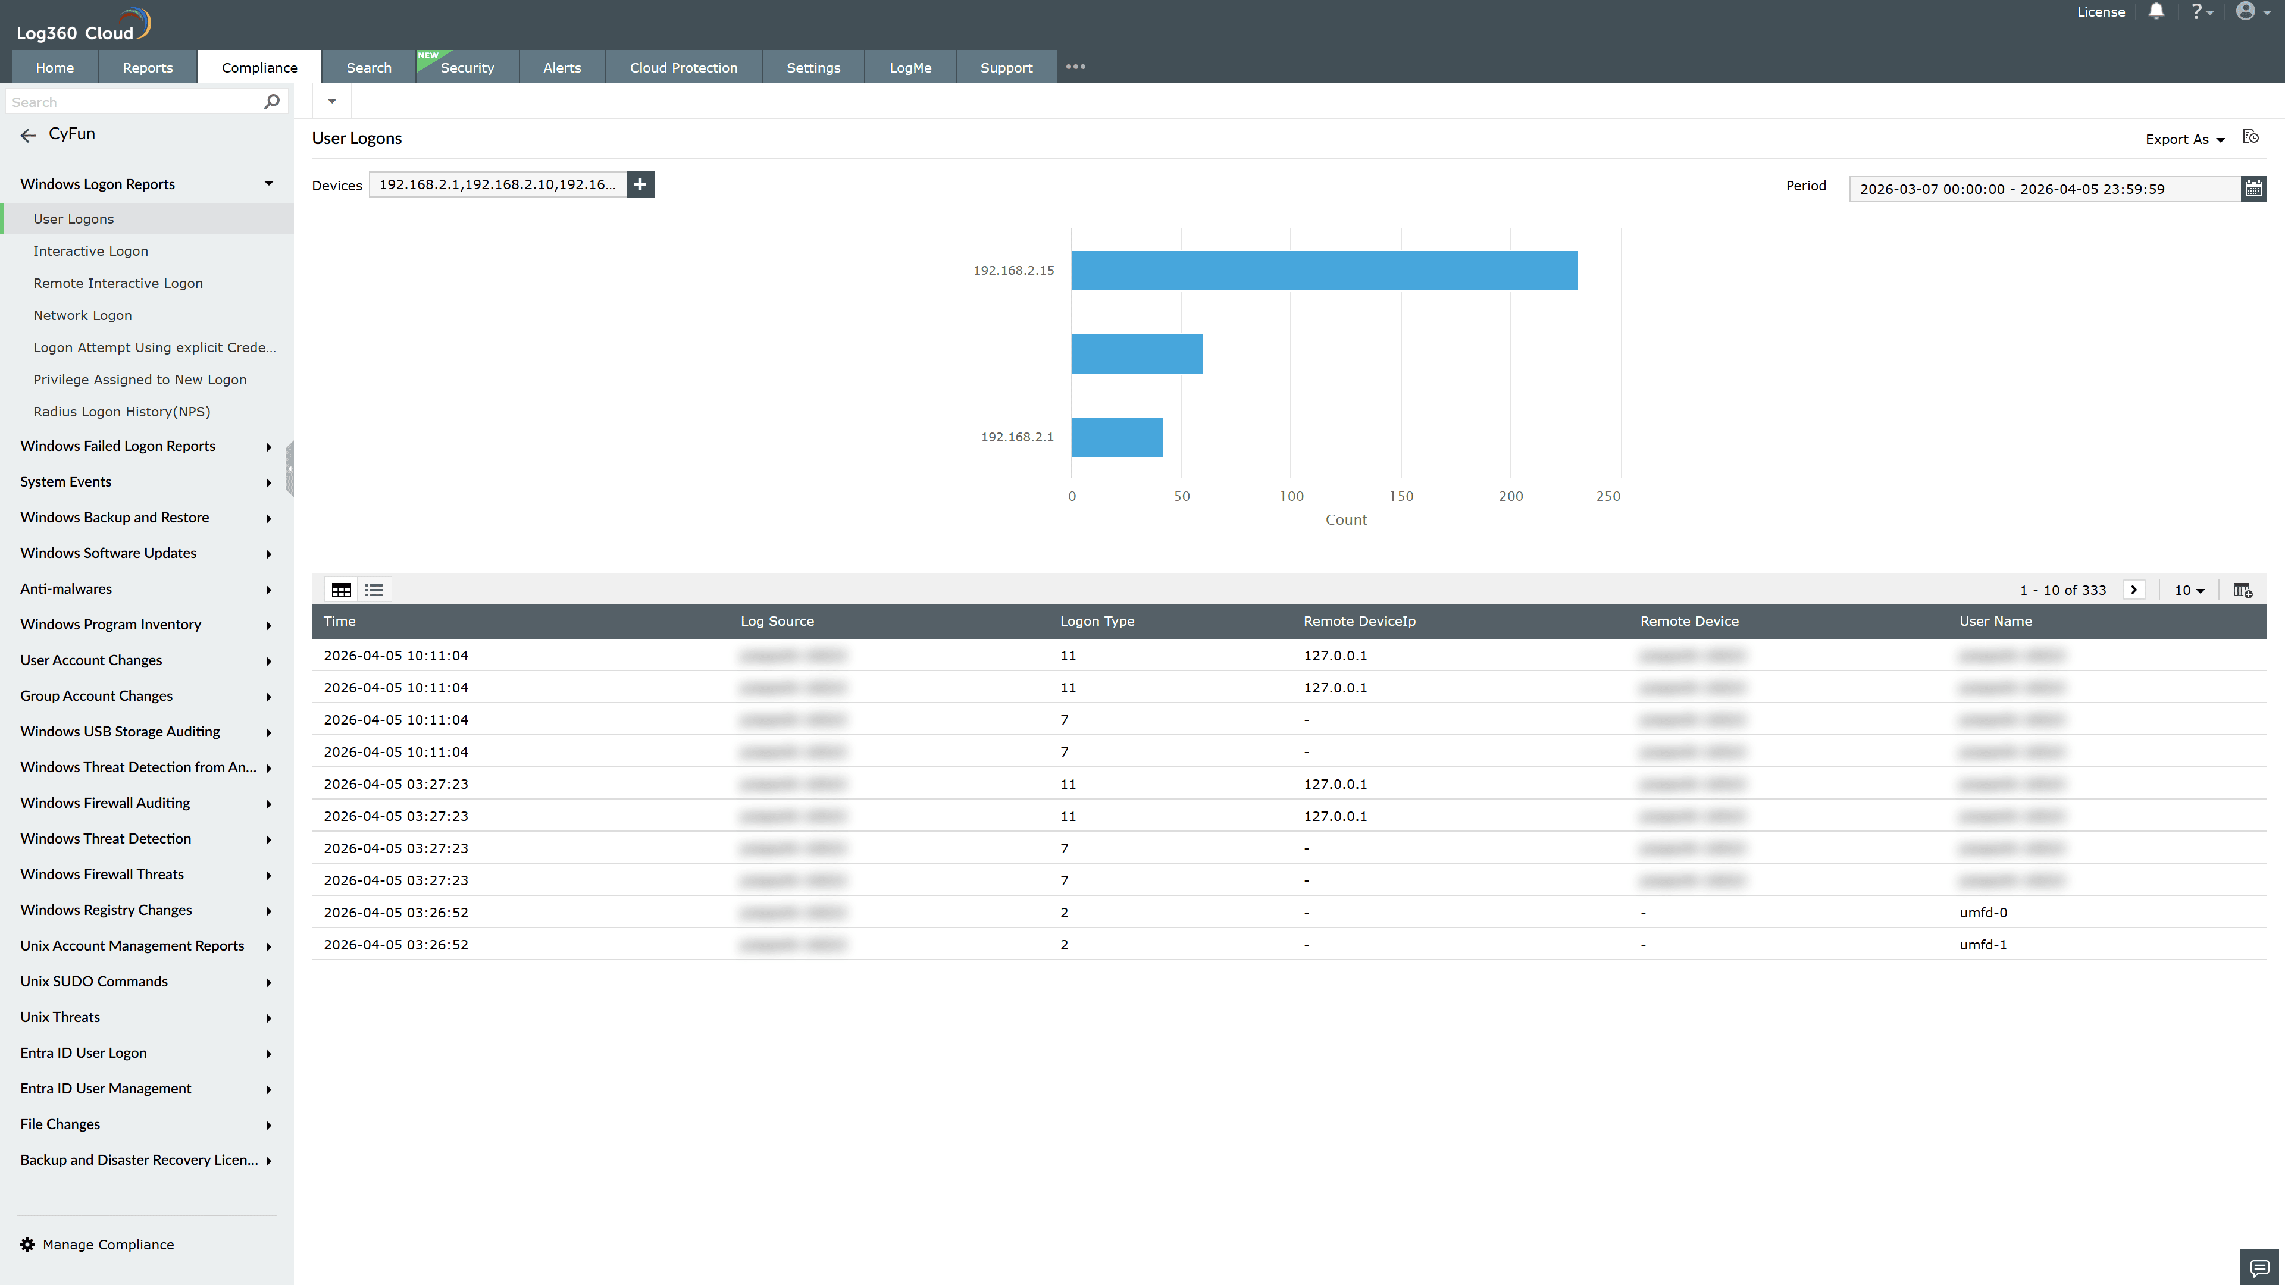
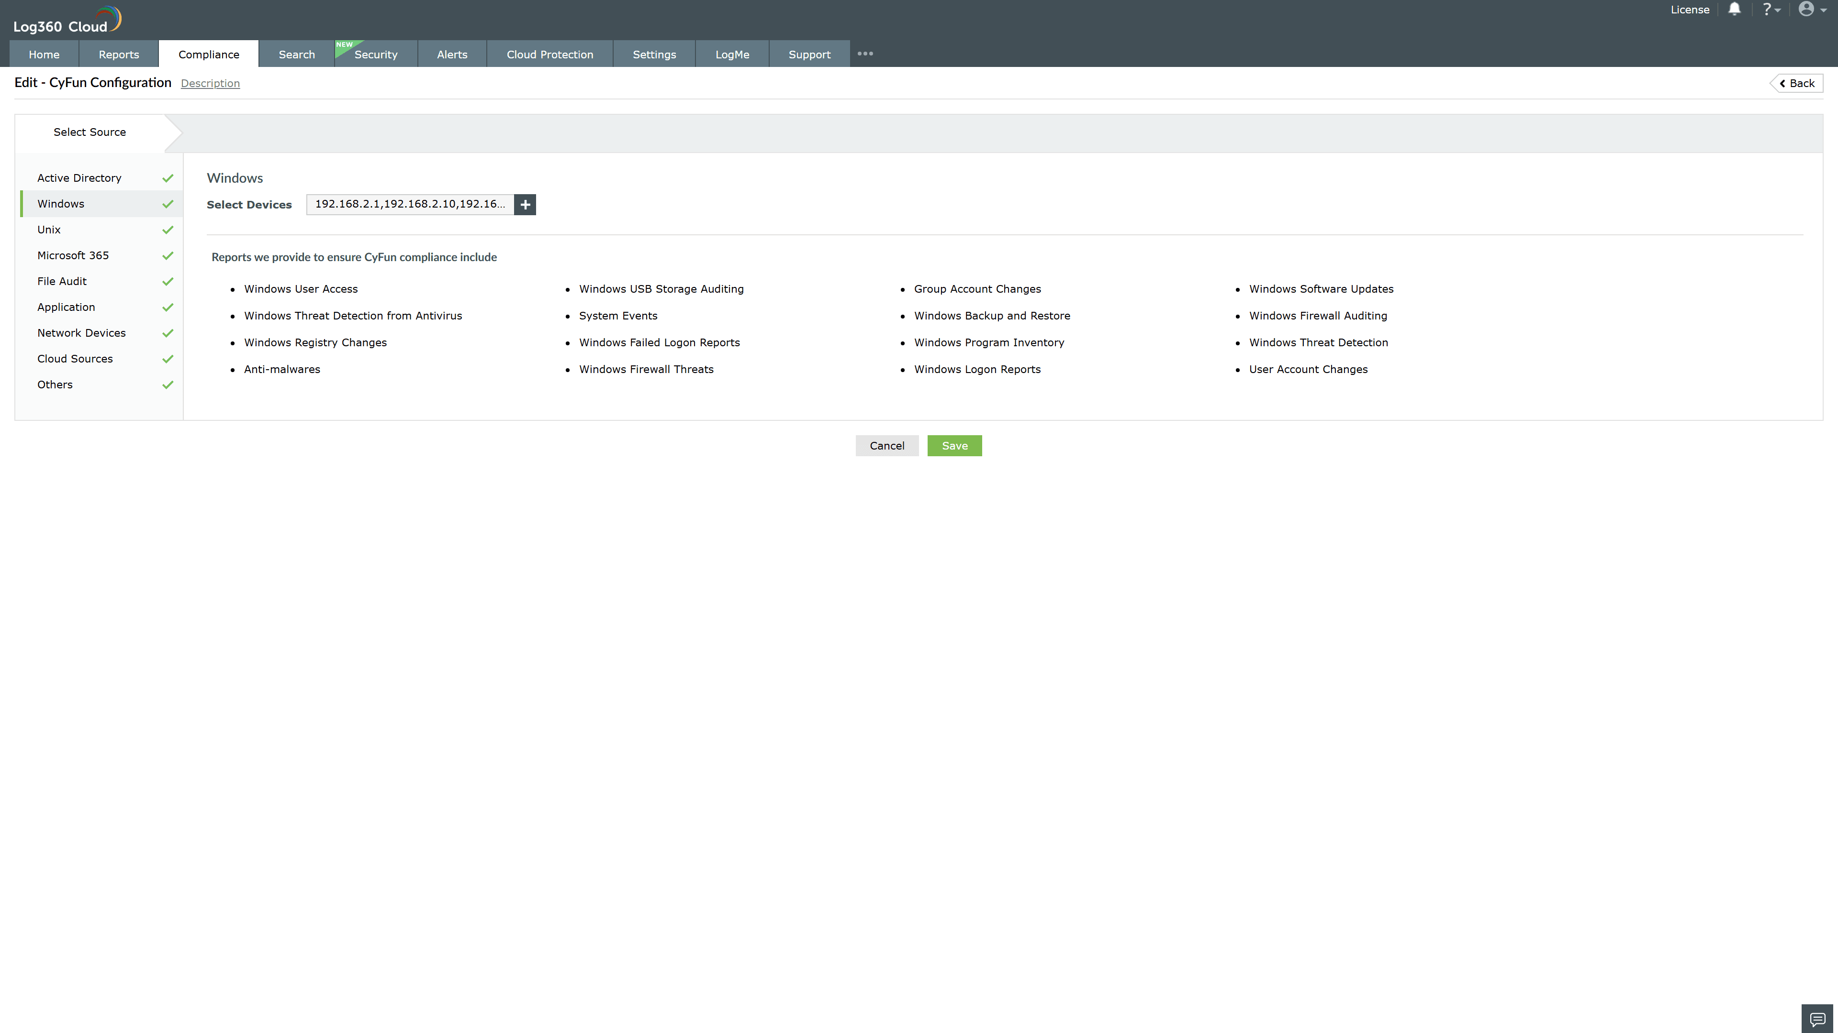
Valid Submission : Yes
Supported Editions : Free, Basic, Standard, Professional, MSSP
Help Document : https://www.manageengine.com/log-management/help/integrations/compliance-extensions.html
Help Video : Not provided
Tags : Log360, Compliance, Privacy monitoring, Data privacy, Regulatory compliance
Supported DCs : US, IN, JP, CA, AU, UK and EU
Privacy Policy:
Terms of Service:
Release Notes:
Predefined reports for the CyFun.

